**Department of Education Administration and Development Faculty of Education**

**Leadership Development and Management**

**National Institute of Education**

**Meepe**

Topic of the assignment :- ICT AND COMMIUNICATION SKILLS

Course cord :- MED 110203

Subject name :- ICT AND COMMIUNICATION SKILLS

Medium :- Sinhala

Type of the Assignment :- Individual

Name of the student :- K.Sobhitha thero

Registration number :- MM 21S0030

**2022**

1 .ප්‍රශ්නය

1. Google docs වෙත යන්න.

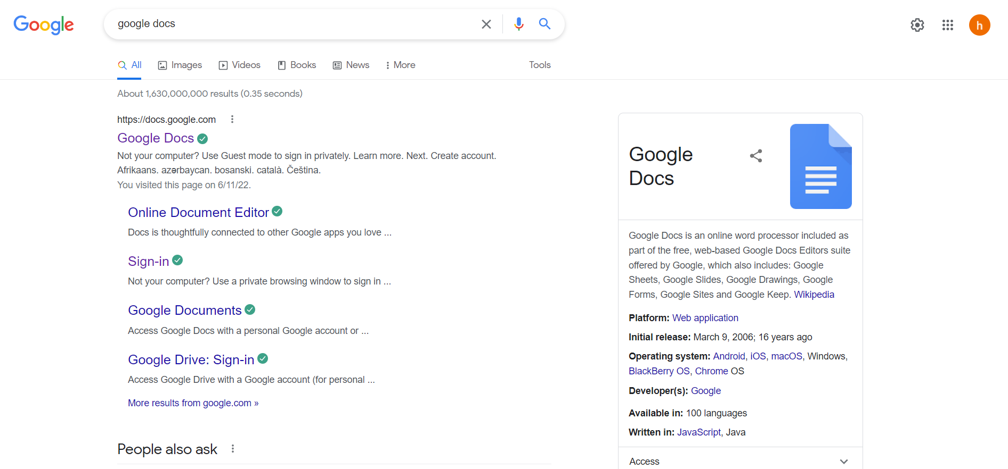

2.Blank sheet 1 තෝරන්න.

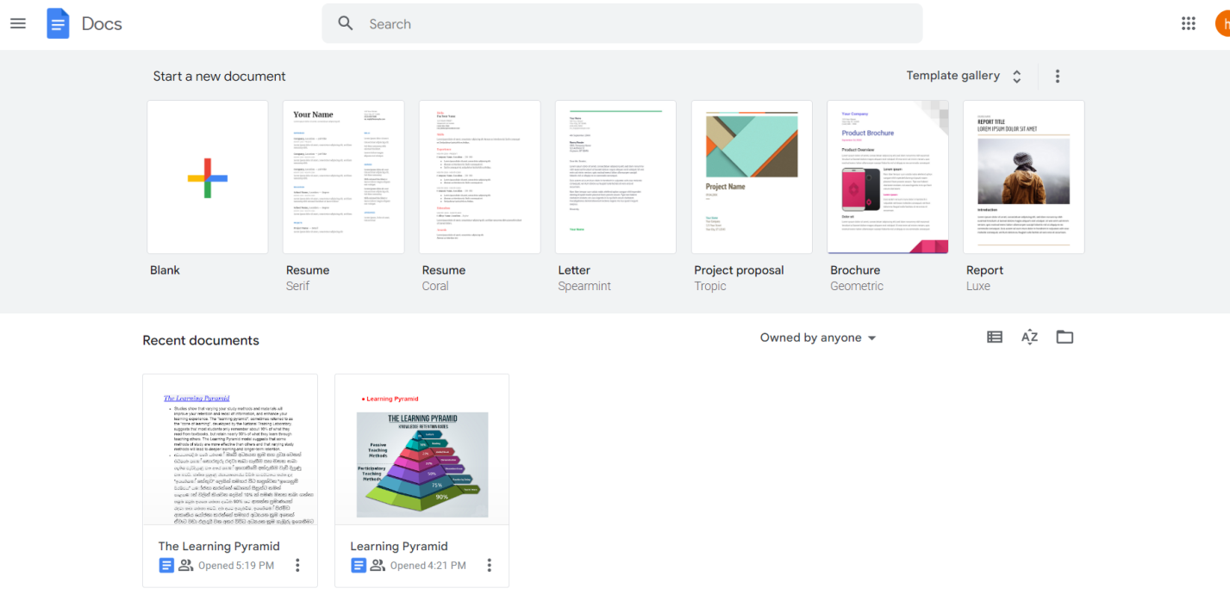

3.Learning pyramid චායාරූපයක් හා එහි විස්තර ඇතුළත් කරන්න.

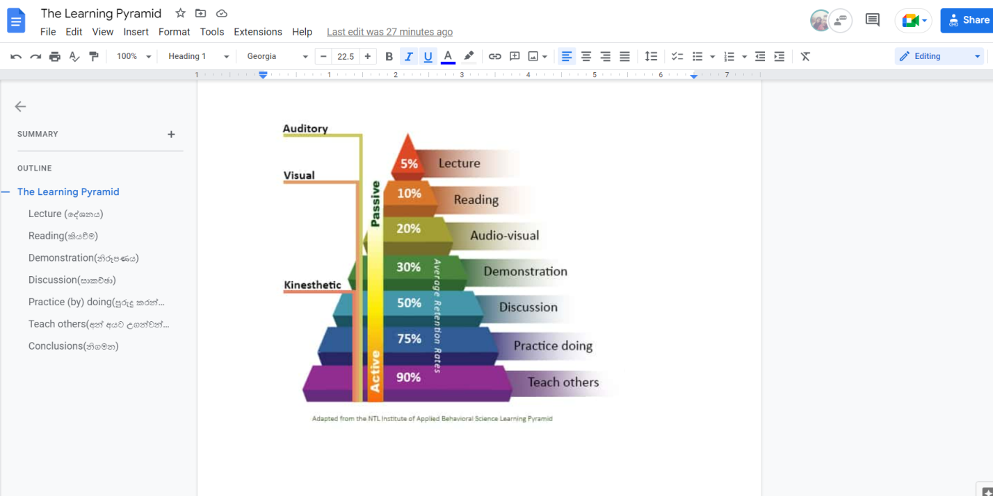

4.මෙය නිර්මාණය කිරීමේදී අනික් අයගේද සහයෝගය ලබාගන්න .

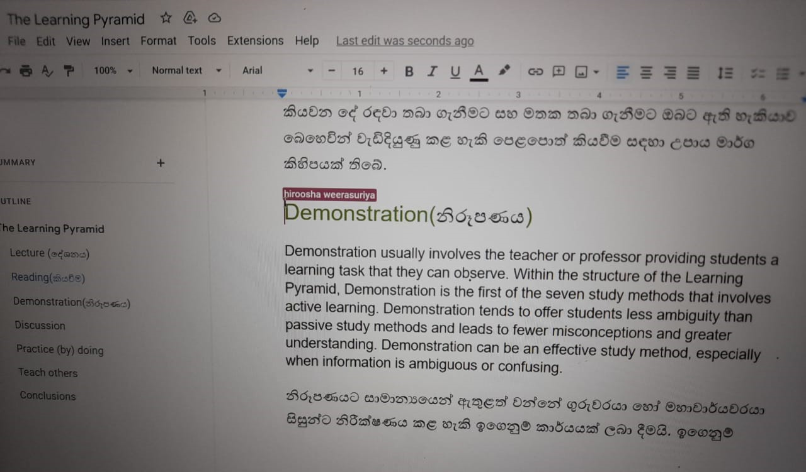

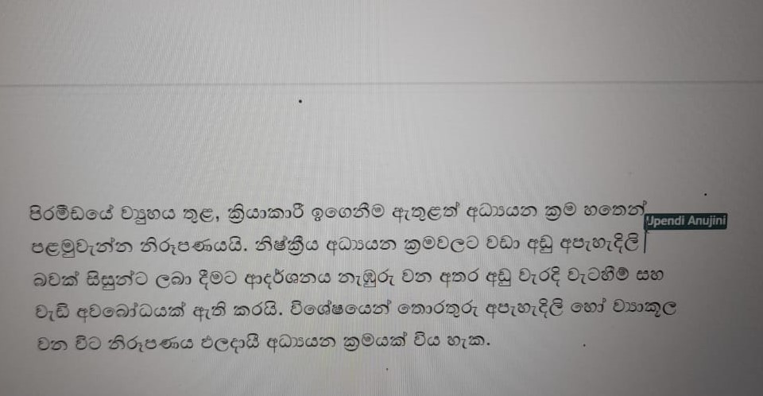

5.Learning Pyramid අදාල link පහතින් දැක්වේ.

[https://docs.google.com/document/d/1YWfkWbEpSGYc_LhTevLNAbrQoFDEcyiowPZUURGBpsg/edit?userstoinvite=jayasinghedeegalla%40gmail.com#](https://docs.google.com/document/d/1YWfkWbEpSGYc_LhTevLNAbrQoFDEcyiowPZUURGBpsg/edit?userstoinvite=jayasinghedeegalla%40gmail.com%23)